CREATE A SIMPLE CLOUD SOFTWARE APPLICATION FOR FLIGHT RESERVATION SYSTEM USING ANY CLOUD SERVICE PROVIDER TO DEMONSTRATE SAAS.

PROCEDURE:

STEP1: GOTO ZOHO.COM
STEP 2: LOGIN TO THE ZOHO.COM
STEP 3: SELECT ONE APPLICATION
STEP 4: ENTER APPLICATION NAME
STEP 5: CREATED NEW APPLICATION
STEP 6: SELECT ONE FORM
STEP 7: THE SOFTWARE HASE BEEN CREATED.

SAMPLE OUTPUT (with Data)

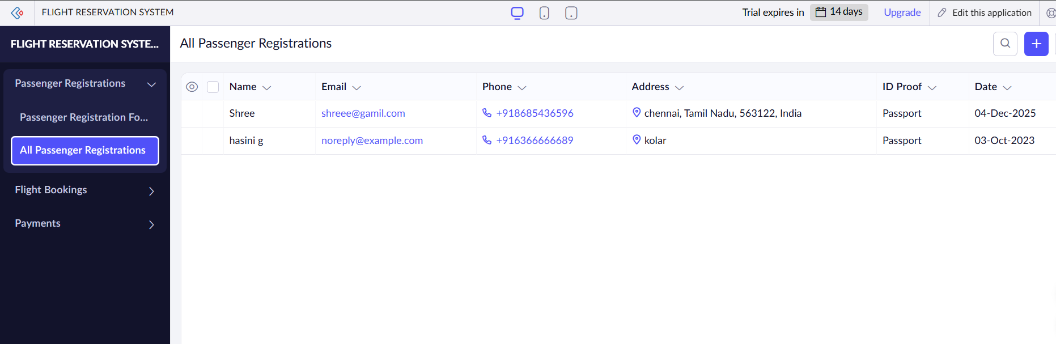

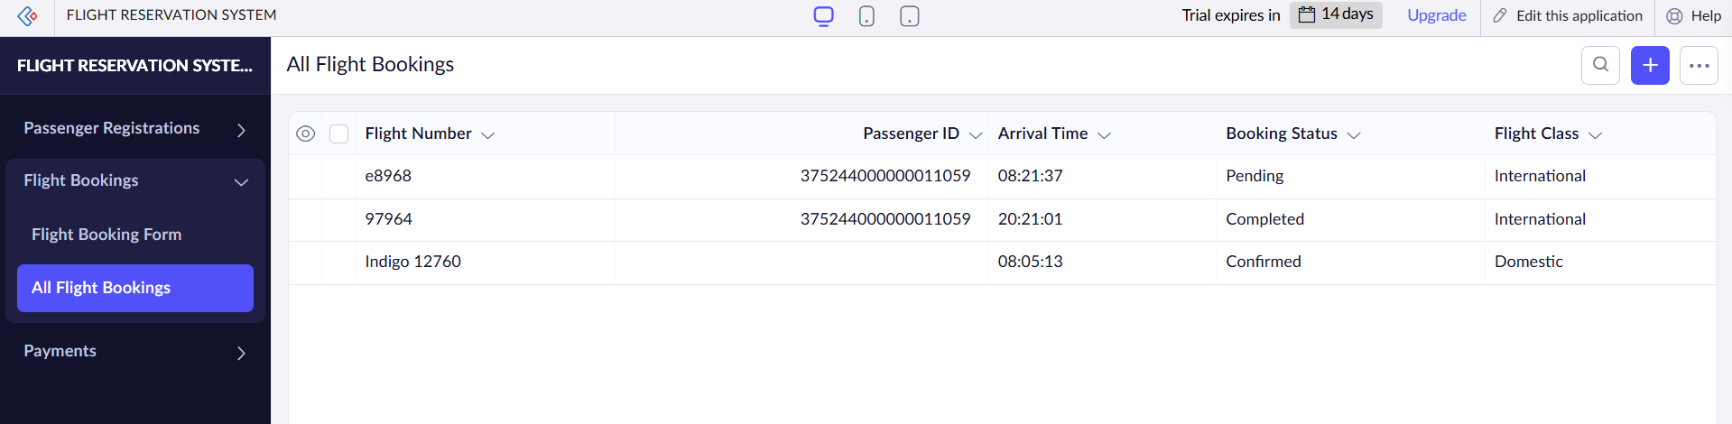

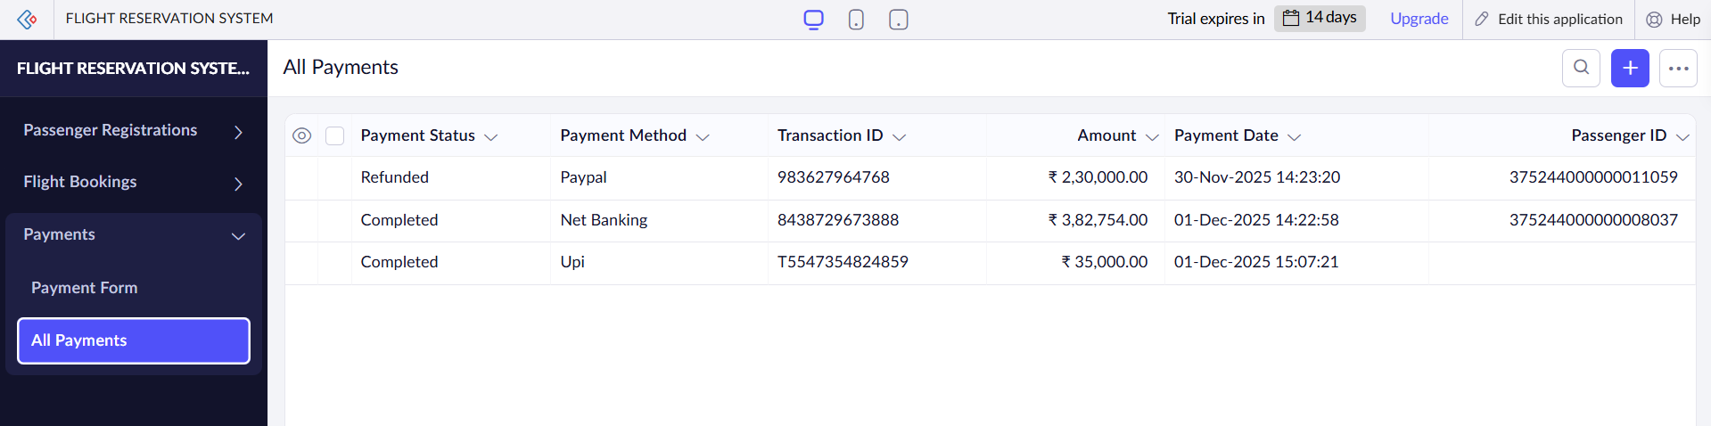

RESULT

Thus the Flight Reservation System is implemented using Zoho Software.

